  Estd: 1986 | 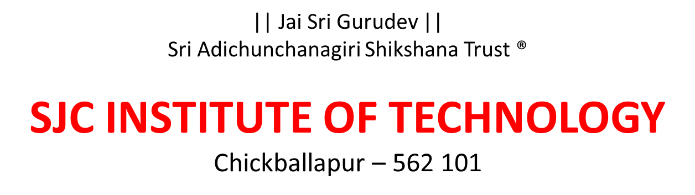
Department of Artificial Intelligence and Data Science

SUBJECT TITLE | DATA SECURITY AND PRIVACY
SUBJECT TYPE | CORE
SUBJECT CODE | BAD703
ACADEMIC YEAR | 2025(ODD SEMESTER) | BATCH | 2022-2026
SCHEME | OBE & CBCS scheme( 2022 scheme)
SEMESTER | VII
FACULTY NAME and DESIGNATION | Prof. Naveen Kumar V G(ASSISTANT PROFESSOR)
QUESTION BANK

Module -1
Q.  No. | Questions | Bloom’s LL | COs
1 | Explain the simplified model of symmetric encryption. | 2 | CO1
2 | Using Hill cipher, perform encryption and decryption for plain text=”SAFE MESSAGES” USING=”CIPHERING” | 3 | CO1
3 | Explain with neat diagram the working of DES encryption algorithm. | 2 | CO1
4 | Explain Ceaser Cipher with example | 2 | CO1
5 | Explain Hill Cipher & apply it to encrypt Plain text = paymoremoney with key  K= 17 17 5  21 18 21  2 2 9 | 3 | CO1
6 | Explain with neat diagram the working of DES encryption algorithm. | 2 | CO1
7 | List and explain the block cipher design principles | 1 | CO1
8 | Explain Playfair Cipher and its rules for the following example:  Ex: Keyword: "Computer" Plaintext: "parrot" | 3 | CO1
9 | What is the one-time pad technique? List the advantages and disadvantages. | 1 | CO1
10 | Explain Feistel encryption and decryption algorithm with neat diagram. | 4 | CO1

Module -2
Q. No. | Questions | Bloom’s LL | COs
1 | Explain the public key cryptosystem with a neat diagram. | 2 | CO2
2 | What is the cipher text if the plain text is 63 and the public key is 13? Use the RSA algorithm. | 3 | CO2
3 | Write about key generation, encryption and decryption in the ElGamal Cryptosystem. | 2 | CO2
4 | List the difference between Conventional and public key encryption | 1 | CO2
5 | Let q=353 and g=3. Xa=97, Xb=233. Use Diffie Hellman Key exchange  algorithm to find Ya, Yb and Secret key K | 3 | CO2
6 | What are the practical issues related to RSA? | 4 | CO2
7 | Explain Public key Encryption And Decryption with example. | 2 | CO2
7 | Explain the Description of RSA Algorithm .Assume 2prime no as p=3 and q=11 encryption key e =3 apply RSA algorithm & find cipher text for the plaintext m=8 & decrypt the cipher text to obtain plain text | 3 | CO2
8 | Explain elliptic curve cryptography algorithm | 2 | CO2
9 | With a neat diagram, explain the key distribution scenario. | 2 | CO2
10 | Explain Elgamal cryptosystem. Perform encryption and decryption using q=19, α=10, K=6, M=17, X_{A}=5, Y_{A}=3 | 3 | CO2

Module -3
Q. No. | Questions | Bloom’s LL | COs
1 | Explain symmetric key distribution using symmetric encryption | 2 | CO3
2 | Explain major issues with key distribution center (KDC). | 2 | CO3
3 | Explain symmetric key distribution using asymmetric encryption | 2 | CO3
4 | Explain different ways of distributing Public keys | 2 | CO3
5 |  | 1 | CO3
  Narrate the core principles can be applied to the framework in all software process.
6 | Explain the use of Control Vector Encryption and Decryption for controlling key usage. Mention its advantages. | 3 | CO3
7 | List and explain the four general categories of schemes for the distribution of public keys. | 1 | CO3
8 | Explain Symmetric Key Distribution Using Asymmetric Encryption with a solution for man in the middle attack | 4 | CO3
9 | With relevant diagram, explain the key distribution scenario. | 2 | CO3
10 | Explain the various techniques used for distribution of public key. | 2 | CO3

Module -4
Q. No. | Questions | Bloom’s LL | COs
1 | Explain benefits and routing applications of IPSec | 2 | CO4
2 | Explain IP security Architecture. | 2 | CO4
3 | Explain Security Associations with SA Parameters | 2 | CO4
4 | Explain how to assess Project Success and Failure in SPM | 5 | CO4
5 | Explain Authentication Header with figure | 2 | CO4
6 | Explain ESP header with figure | 2 | CO4
7 | Explain transport mode & Tunnel Mode of IPsec | 2 | CO4
8 | Analyze a TLS handshake message sequence and explain each step. | 4 | CO4
9 | Given a simulated packet capture, identify IPsec-protected traffic. | 3 | CO4
10. | Discuss Internet Key Exchange phases. | 2 | CO4

Module -5
Q. No. | Questions | Bloom’s LL | COs
1 | Define innocuous text. List any two applications of data hiding. | 1 | CO5
2 | Explain simple digital methods for data hiding in text. | 2 | CO5
3 | Describe mimic functions with an example. | 2 | CO5
3 | Explain LSB encoding with an example. | 3 | CO5
4 | Compare watermarking and steganography. | 4 | CO5
5 | Discuss lossless data hiding techniques. | 2 | CO5
6 | Explain simple digital methods for data hiding in text. | 2 | CO5
7 | Hide the message “DATA” in an image using LSB substitution (given pixel data).. | 3 | CO5
8 | Design a simple text steganography method using spaces and tabs. | 6 | CO5
9 | Apply BPCS steganography on a given image and explain results. | 3 | CO5
10 | What is LSB encoding in image steganography? | 1 | CO5

Note:

- Questions shall be framed by consolidating comprehensively from the following sources
- Exercise problems of text books/ references
- Previous year question VTU exam Question paper. (Mark the year/exam beside the question)
- Questions by Experts during Interview/Academic Audit
- Internet sources/ other Universities examination question papers.
- Own / experience.
- Gate questions mentioning the year.
- Questions shall follow all the Bloom’s learning levels with appropriate action verbs
- There shall be a total of 50 questions considering10 questions from each module, of
Which , 3 questions each at L1 and L2, 2 questions at L3, 1 question each at L4 and L5/L6.
- Ensure the coverage of all Cos.

